*(10) The analyst vs User Interface.*

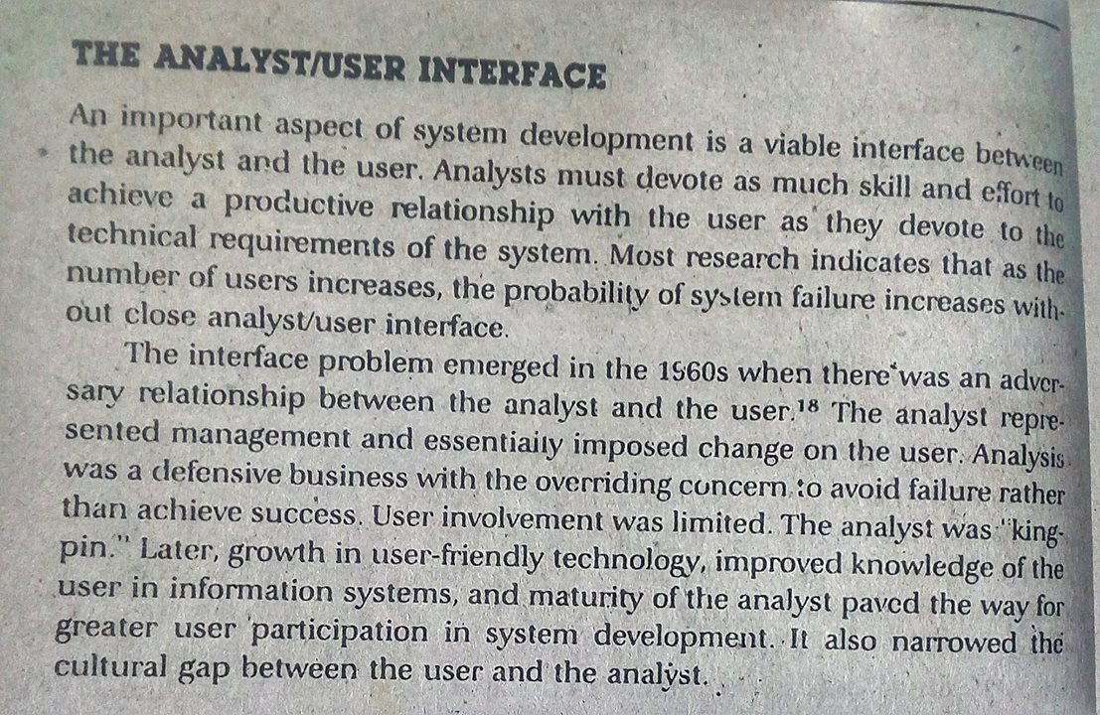

P - 70